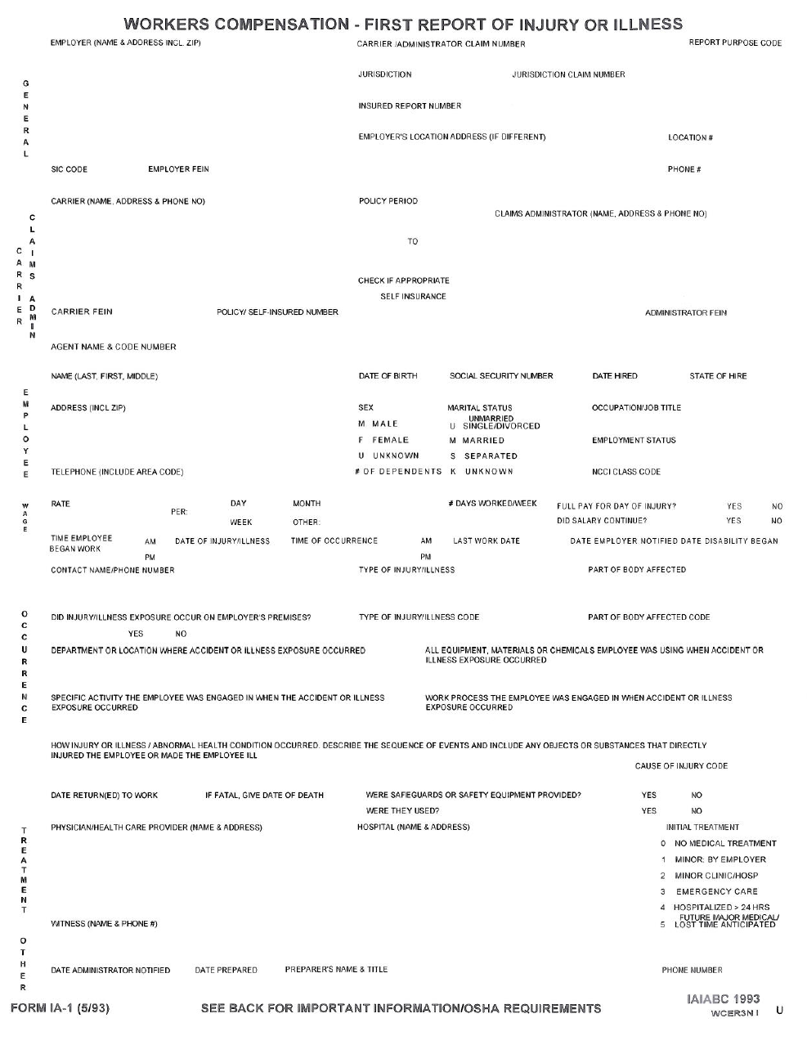

Employee states

